Module 3.
Configuring Jenkins

Technical requirements

• Java 8+
• At least 4 GB of RAM
• At least 1 GB of free disk space
• Docker Engine installed

What is Jenkins?
Jenkins is an open source automation server written in Java. With very active community-based support and a huge number of plugins, it is one of the most popular tools for implementing continuous integration and continuous delivery processes.

Let's walk through the most interesting parts of Jenkins' characteristics:

• Language-agnostic: Jenkins has a lot of plugins, which support most programming languages and frameworks. Moreover, since it can use any shell command and any software, it is suitable for every automation process imaginable.

• Extensible by plugins: Jenkins has a great community and a lot of available plugins (over a thousand). It also allows you to write your own plugins in order to customize Jenkins for your needs.

• Portable: Jenkins is written in Java, so it can be run on any operating system. For convenience, it is also delivered in a lot of versions – Web Application Archive (WAR) files, Docker images, Helm charts, Kubernetes operators, Windows binaries, macOS binaries, and Linux binaries.

• Supports most Source Control Management (SCM) tools: Jenkins integrates with virtually every source code management or build tool that exists. Again, because of its large community and number of plugins, there is no other continuous integration tool that supports so many external systems.

• Distributed: Jenkins has a built-in mechanism for the master/agent mode, which distributes its execution across multiple nodes, located on multiple machines. It can also use heterogeneous environments; for example, different nodes can have different operating systems installed.

• Simplicity: The installation and configuration process is simple. There is no need to configure any additional software or the database. It can be configured completely through a GUI, XML, or Groovy scripts.

• Code-oriented: Jenkins pipelines are defined as code. Also, Jenkins itself can be configured using YAML/XML files or Groovy scripts. That allows you to keep the configuration in the source code repository and helps in the automation of the Jenkins configuration.

Installing Jenkins
There are different methods of installing Jenkins, and you should choose the one that best suits your needs. Let's walk through all the options you have and then describe the most common choices in detail:

• Servlet: Jenkins is written in Java and natively distributed as a web application in the WAR format, dedicated to running inside an application server (such as Apache Tomcat or GlassFish); consider this option if you deploy all your applications as servlets.

• Application: The Jenkins WAR file embeds the Jetty application server, so it can be directly run with the Java command, and therefore, the Java Runtime Environment (JRE) is the only requirement to start Jenkins; consider this option if you use bare-metal servers and/or you need to install multiple Jenkins instances on one machine.

• Dedicated package: Jenkins is distributed for most operating systems in a form of dedicated packages (MSI for Windows, the Homebrew package for macOS, the deb package for Debian/Ubuntu, and so on); consider this option for the simplest installation and configuration if you use bare-metal servers.

• Docker: Jenkins is distributed in a form of a Docker image, and so the only requirement is to have Docker installed; consider this option for the simplest installation if you use Docker in your ecosystem.

• Kubernetes: Jenkins provides a Helm chart and a Kubernetes operator to simplify its installation, management, and scaling in a Kubernetes cluster; consider this option for the simplest Jenkins scaling and management.

• Cloud: Jenkins is hosted in a form of Software as a Service (SaaS) by a number of platforms; consider this option if you don't want to think about server maintenance and Jenkins installation.

Information
You can find a detailed description of each installation method at https://www.jenkins.io/doc/book/installing/

Installing Jenkins with Docker
The Jenkins image is available in the Docker Hub registry, so in order to install its latest version, we should execute the following command:

Master and agents
Jenkins becomes overloaded sooner than it seems. Even in the case of a small (micro) service, the build can take a few minutes. That means that one team committing frequently can easily kill the Jenkins instance.
For that reason, unless the project is really small, Jenkins should not execute builds at all but delegate them to the agent (slave) instances. To be precise, the Jenkins server we're currently running is called the Jenkins master, and it can delegate execution tasks to Jenkins agents.

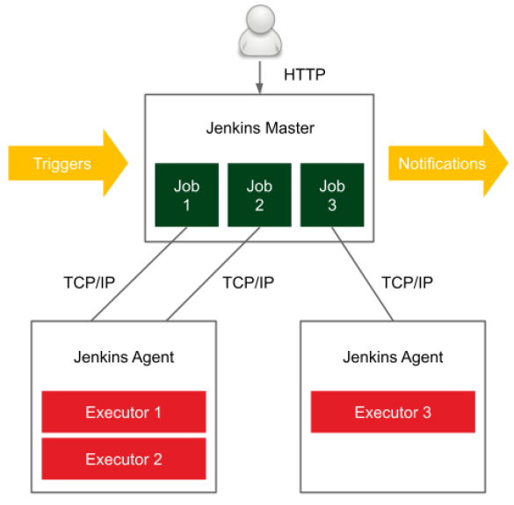

Figure 1 – The Jenkins master-agent interaction

In a distributed build environment, the Jenkins master is responsible for the following:

• Receiving build triggers (for example, after a commit to GitHub)
• Sending notifications (for example, email or Slack messages sent after a build failure)
• Handling HTTP requests (interaction with clients)
• Managing the build environment (orchestrating the job executions on agents)

The build agent is a machine that takes care of everything that happens after the build has started.

Configuring agents
You've seen what the agents are and when they can be used. However, how do we set up an agent and let it communicate with the master?

Communication protocols
In order for the master and the agent to communicate, a bidirectional connection has to be established.

There are different options for how it can be initiated:

• SSH: The master connects to the agent using the standard SSH protocol. Jenkins has an SSH client built in, so the only requirement is the SSH daemon (sshd) server configured on the agents. This is the most convenient and stable method because it uses standard Unix mechanisms.

• Java web start: A Java application is started on each agent machine, and the TCP connection is established between the Jenkins agent application and the master Java application. This method is often used if the agents are inside the firewalled network and the master cannot initiate the connection.

Setting agents

• Static versus dynamic: The simplest option is to add agents permanently in the Jenkins master. The drawback of such a solution is that we always need to manually change something if we need more (or fewer) agent nodes. A better option is to dynamically provision agents as they are needed.

• Specific versus general-purpose: Agents can be specific (for example, different agents for the projects based on Java 8 and Java 11) or general-purpose (an agent acts as a Docker host and a pipeline is built inside a Docker container).

